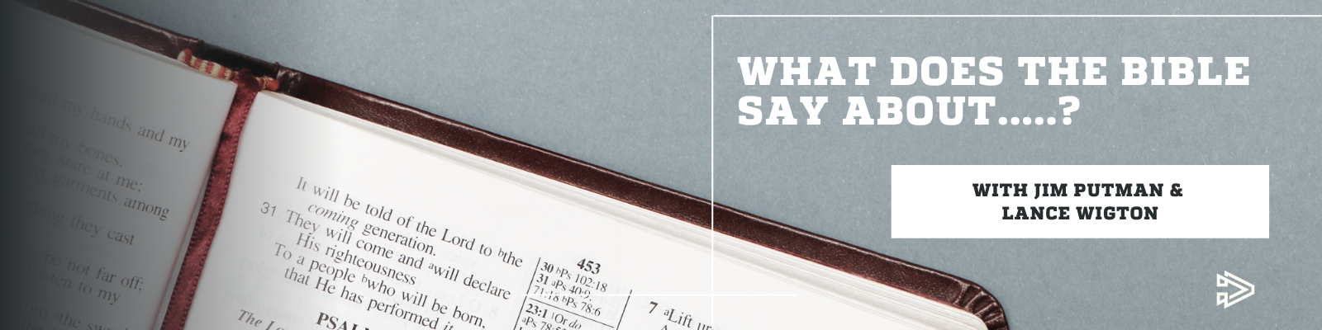

What Does the Bible Say About...... Communion – Show Notes

In Episode One of our new podcast, Lance Wigton - Communication Director at Real Life Ministries, and Jim Putman - Senior Pastor at Real Life Ministries, come together to discuss the element of Communion. What does the Bible say about it and why do we offer it every week at Real Life?

At Real Life Ministries, we offer communion every week during our services. The reason for this is that it was modeled that way by the early church according to scripture.

Acts 20:7 “On the first day of the week, we gathered with the local believers to share in the Lord’s Supper. Paul was preaching to them, and since he was leaving the next day, he kept talking until midnight.”

1 Corinthians 11:25 “In the same way, he took the cup of wine after supper, saying, “This cup is the new covenant between God and his people – an agreement confirmed with my blood. Do this in remembrance of me as often as you drink it.” For every time you eat this bread and drink this cup, you are announcing the Lord’s death until he comes again.”

Here are some of benefits we see in taking communion every week:

- It’s a weekly reminder of what Jesus did for us by dying on the cross.
- It is like preaching the gospel every week – it gives us a chance to celebrate and reflect on that.
- It is a way of spiritually abiding in Christ and acknowledging that we need Him.
- It gives us a time every week to check ourselves – and to remember that we are in need of a Savior.

Thank you for tuning in to our podcast! If you would like to find out more about Real Life Ministries, plan a visit, or view our doctrinal statement you can do so by going to the link below:

https://www.reallifeministries.com/who-we-are

If you would like to access more resources about discipleship, including podcasts, sermons, books and bog posts you can go to the link below:

https://realliferesources.org/

You may also be interested in:

https://realliferesources.org/podcast/what-is-a-disciple-the-real-life-discipleship-podcast-episode-002/

https://realliferesources.org/podcast/small-group-vs-bible-class-whats-the-difference-and-do-i-need-both-podcast-small-group-vs-bible-study-whats-the-difference/

https://realliferesources.org/the-disciples-journey/

Have more questions or something you would like Jim and Lance to address?
Contact us at realforlife@reallifeministries.com

