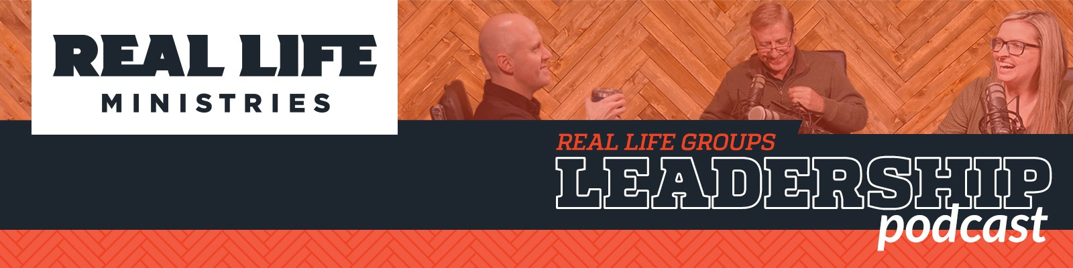

Season 2 Episode 4 Part 1: Promoting Mental Health in Your Group

In this episode Chris Short - Executive Pastor at Real Life Ministries is joined by Santha Yinger: Mental Health & Wellness Ministry Lead, and Mike Wraith: Licensed Clinical Social Worker (and Life Group leader!)

In this episode they are talking about the very important topic of promoting mental wellness in your Life Group. Some of the things they cover are:

Why does our awareness of mental health matter when it comes to leading a life group?

Everyone has the need for Mental Wellness, and every one of us has a Mental Health that God has given us to steward, just as we are responsible for our physical health and well being.

We need to be careful not to label people - there is a stigma when it comes to mental health, but we need to approach it just as we would any physical struggle or illness.

Community is a key factor to Mental Health, but it takes time to build it. Life Groups provide an opportunity for connection, especially when they are places where the members can be transparent and feel safe.

As group leaders, we need to become students of the patterns of the people in the group. If we are able to recognize their patterns we will be able to notice when things are off.

Remember that the responsibility for the people in your group is not all on your shoulders! Encourage relationships and connections to develop between the different members as they spend time together inside and outside of group. And don't forget that you always have your coaches and campus leaders to turn to if you have questions or needs.

Registration is opening soon for our Mental Health Response Basics Class happening at our Post Falls Campus. Gain some basic understanding of recognizing stressors, symptoms of mental distress, some basic responses, wellness practices and de-escalation techniques. Check it out here: https://www.reallifeministries.com/classes

We also have some great tools that our leadership have made available for you to use!

- Right Now Media: (The Netflix of Bible Studies)
Real Life has gifted our people with a free membership to this platform! Find out more at this link. https://app.rightnowmedia.org/en/user/reallifeministries

- Real Life Resources: This digital library contains over 500 tools and resources to help both you personally and those in your group. Podcasts, videos, books, studies and much more at this link. https://realliferesources.org/

If you have any questions or suggestions for future topics, feel free to email us at: realforlife@reallifeministries.com.

